Firewall Configuration Document

General Information
Project Name | Environment | Prepared By | Date
Team 7 Network | Controlled | Flynn Collins | 11/11/2025

Firewall Zones
LAN Zone: 192.168.150.0/24
DMZ Zone: 10.17.200.0/24
WAN Zone: 192.168.208.0/24

Access Rules
Source Zone | Destination Zone | Source Address | Destination Address | Application | Service | Action | Profiles
LAN | WAN | any | any | any | any | Allow | Security Profile Group
WAN | DMZ | any | 10.17.200.50 | any | any | Allow | Security Profile Group
LAN | DMZ | 192.168.150.0/24 | 10.17.200.50 | any | any | Allow | Security Profile Group
DMZ | LAN | 10.17.200.0/24 | 192.168.150.0/24 | any | any | Deny | Security Profile Group

NAT Policies
Name | Source Zone | Destination Zone | Source Translation | Destination Translation
LAN to WAN | LAN | WAN | dynamic-ip-and-port (ethernet1/1) | Automatic.
WAN to DMZ | WAN | DMZ | none | static (10.17.200.50)
DMZ to WAN | DMZ | WAN | dynamic-ip-and-port (ethernet1/1) | Automatic.

Zone Protection Profiles
LAN Protection: SYN Flood, UDP Flood, ICMP Flood enabled; TCP Port Scan and Host Sweep set to alert.
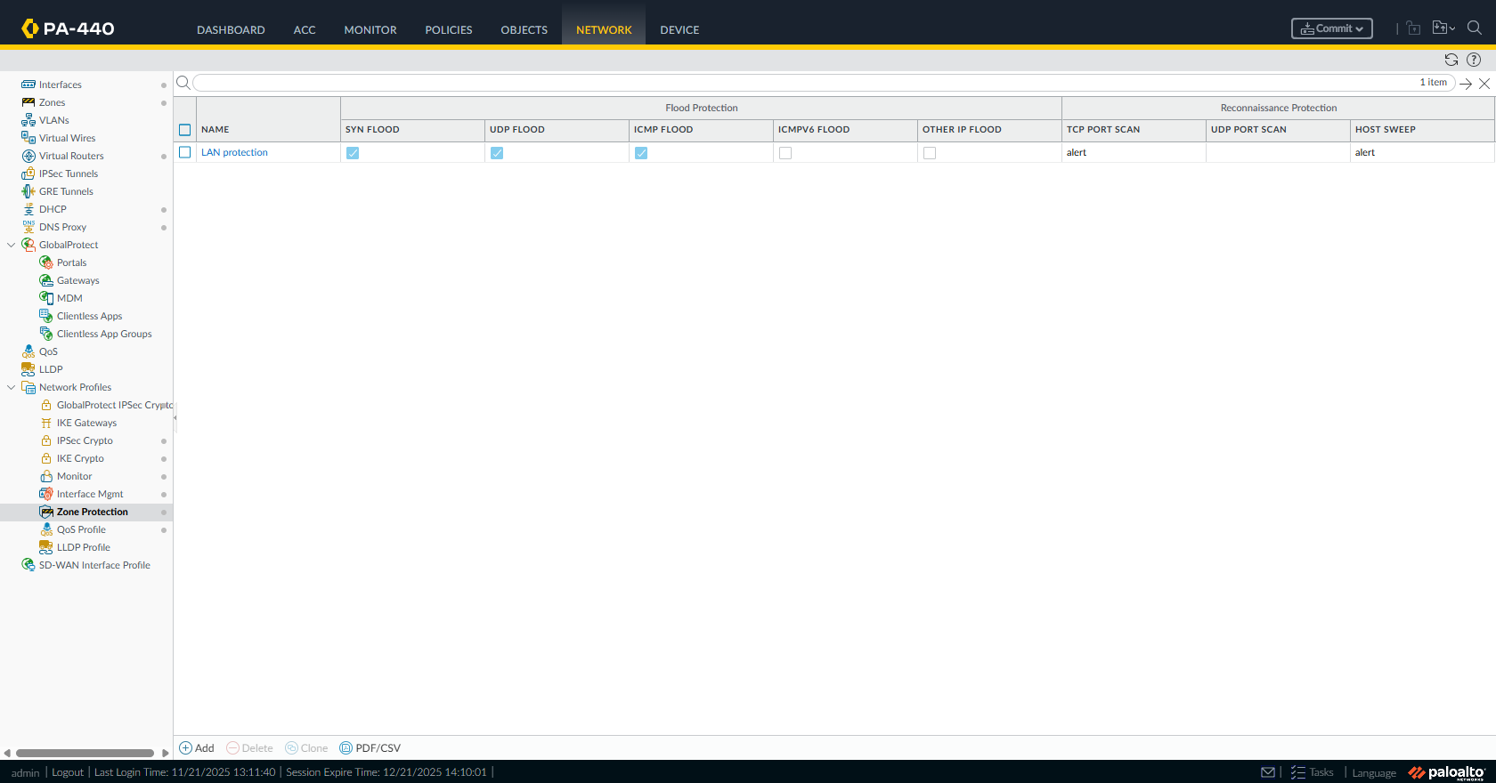

Interface Management Profiles
Zone | Allowed Management Services
LAN | Ping, SSH, HTTPS
DMZ | Ping, SSH, HTTPS
WAN | None.

Security Profiles
Antivirus: Custom Profile enabled.
Anti-Spyware: Custom profile enabled.
Vulnerability Protection: Custom profile enabled.
URL Filtering: Block malware, phishing, adult categories etc.
File Blocking: Block executable files from unknown sources.
DOS Protection: Syn flood, udp flood, icmp flood, and more protection all enabled.

Security Profile Group
Name: SecProfile
Includes: Antivirus, Anti-Spyware, Vulnerability Protection, URL Filtering, File Blocking, and DOS protection.
Antivirus
- Custom Profile
- Action for malware = Block
- Covers HTTP/HTTPS, SMTP, SMB
- WildFire inline analysis enabled
Anti-Spyware
- Custom profile
- DNS sinkhole enabled
Vulnerability Protection
- Critical + High severity = block
- Medium severity = alert
URL Filtering
Block:
- Malware
- Phishing
- Adult content
- Terrorism
- Guns
- Unknown sites (optional)
Allow:
- Business, Education, Cloud categories
File Blocking
- Block exe, dll, scr, and .bat from unknown/uncategorised sources
- Alert on PDF, Office files
DoS Protection
- SYN Flood
- UDP Flood
- ICMP Flood
- Resource protection enabled

Log Forwarding
Syslog forwarding enabled for Threat, Traffic, and URL logs to Elastic Agent / Logstash for SIEM integration.

Dynamic Updates
Applications & Threats: Daily
Antivirus: Daily
WildFire: Every 5 minutes
URL Filtering: Daily

Contacts
Name | Role | Email
Flynn | Firewall Configurator | 13220281@gordontafe.edu.au

